***Webinar Login Process Document***

***Step 1***:

Once we trigger emails regarding the respective session, you will be receiving ***registration link*** through email to your ***registered email id with EPAM*** (eg: rajesh_gannamani@epam.com).

Please click on the ***registration link*** and you will be redirected to webinar registration form for the respective session.

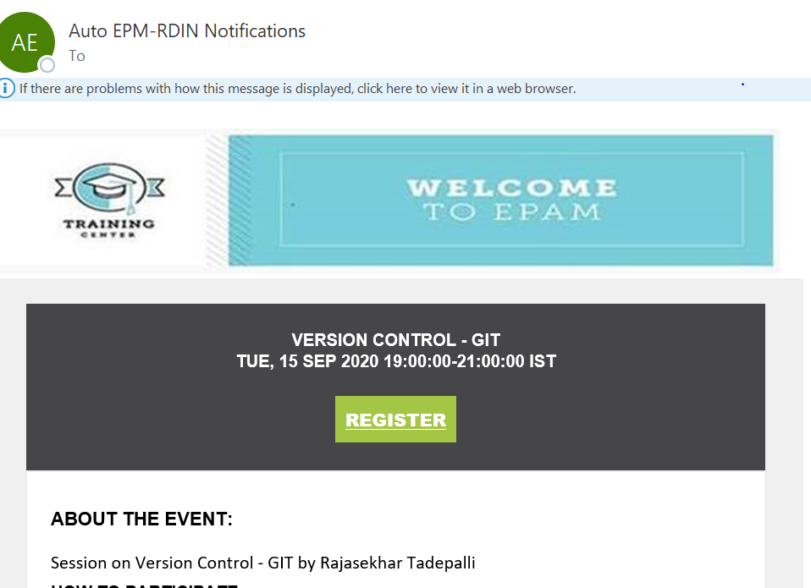

***Step 2***:

Please do enter your first and last name along with your registered email ID with EPAM to avoid any attendance discrepancies ***(Please do not enter any email id apart from your registered email ID ; eg:*** [***rajesh_gannamani@epam.com***](mailto:rajesh_gannamani@epam.com) ***as shown in Step 1).***

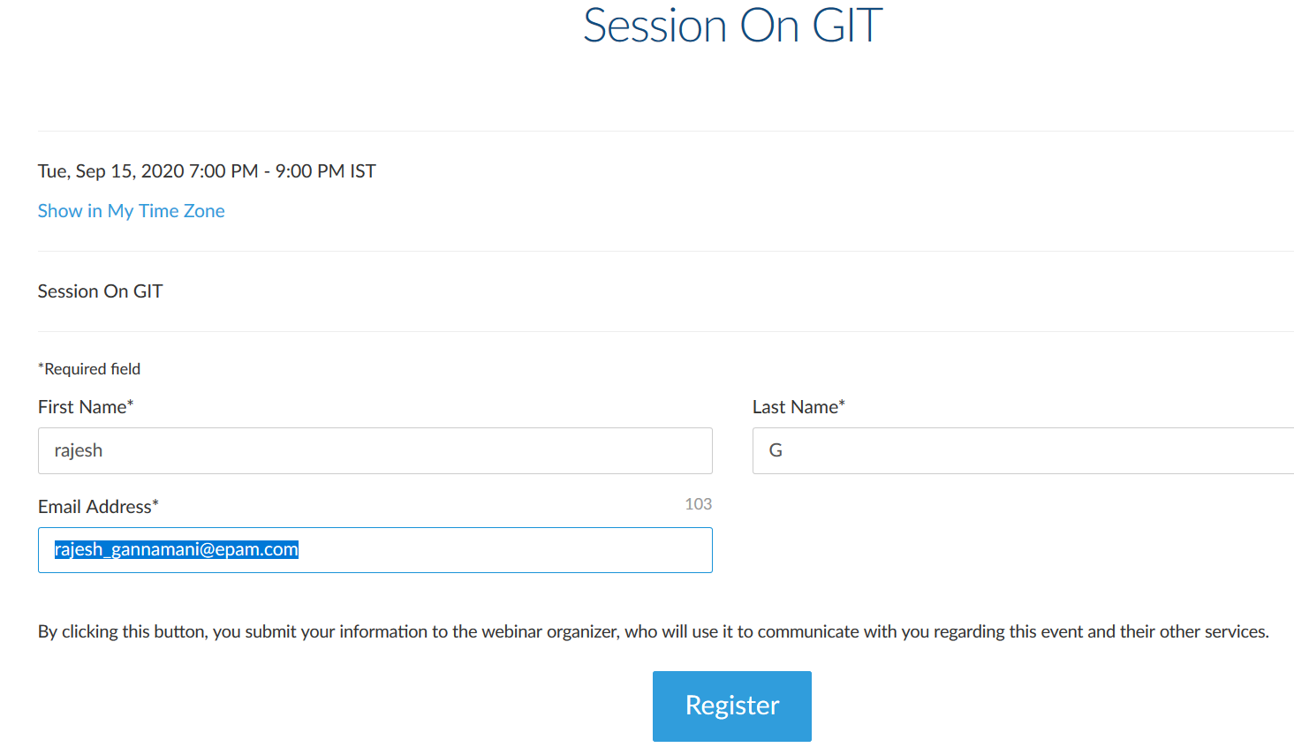

***Step 3***:

Once you get registered, you will be getting ***participation link*** to your ***registered email id*** (eg: rajesh_gannamani@epam.com) which has “***Join Webinar***” icon in it.

Click on “***Join Webinar***” at the respective time on which the session is scheduled.

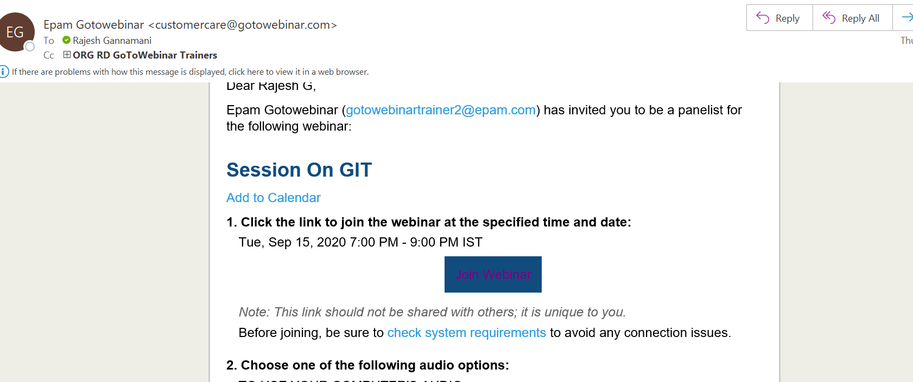

***Note: Throughout the process of logging in to webinar session mentioned above, only one email id (registered with EPAM) has been used.***